**Practical no 1**

Aim: To use Bayes’ theorem in probability and to find covariance and correlation of random variables

Name: Neeraj Sanjay Shah

Roll No: 51

Class: F.Y. Data Science

Sub: Probability and distributions

Sign:

**A)** **Formulate and apply Bayes’ Theorem Calculations for problems like The “Two-Supplier Example”. [Hint: Use Prior Probabilities and Conditional Probabilities to computeJoint and PosteriorProbabilities.]**

Q1. A bag I contains 4 white and 6 black balls while another Bag II contains 4 white and 3 black balls. One ball is drawn at random from one of the bags, and it is found to be black. Find the probability that it was drawn from Bag I.

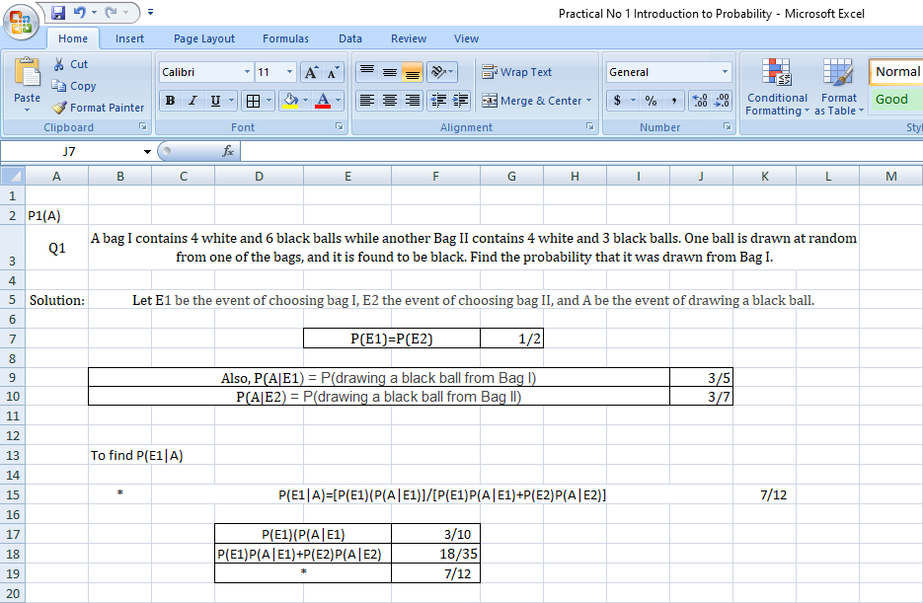

Q.2 A man is known to speak the truth 2 out of 3 times. He throws a die and reports that the number obtained is a four. Find the probability that the number obtained is actually a four.

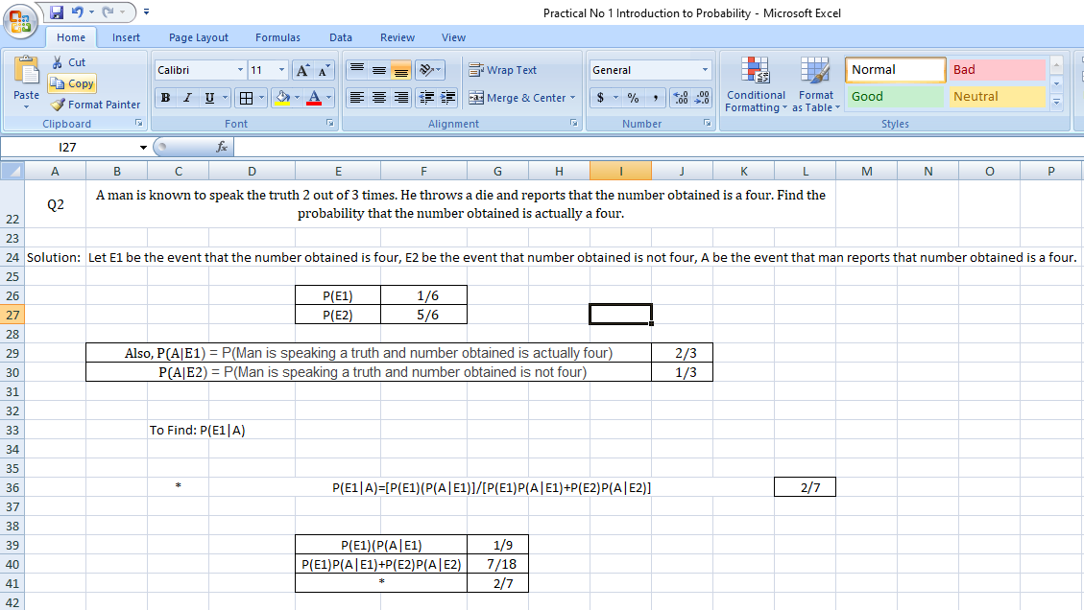

**B)** **Design spreadsheet to demonstrate the association Between Two Variables by Computing the Covariance and Correlation Coefficient.**

**[Hint: Use COVAR and CORREL)]**

